Compilar Conector PGE con Eclipse 2018-09 (4.9.0).

- Dentro de Eclipse ir a Help _ Eclipse Marketplace
- Instalar Spring Tool Suite 4.
- Desinstalar buildship gradle integration 3.0
- Instalar Gradle ide pack 3.8.x

- Importar el proyecto desde el directorio como proyecto gradle:
- File_Import_Gradle (STS)_Gradle (STS) Project_Next

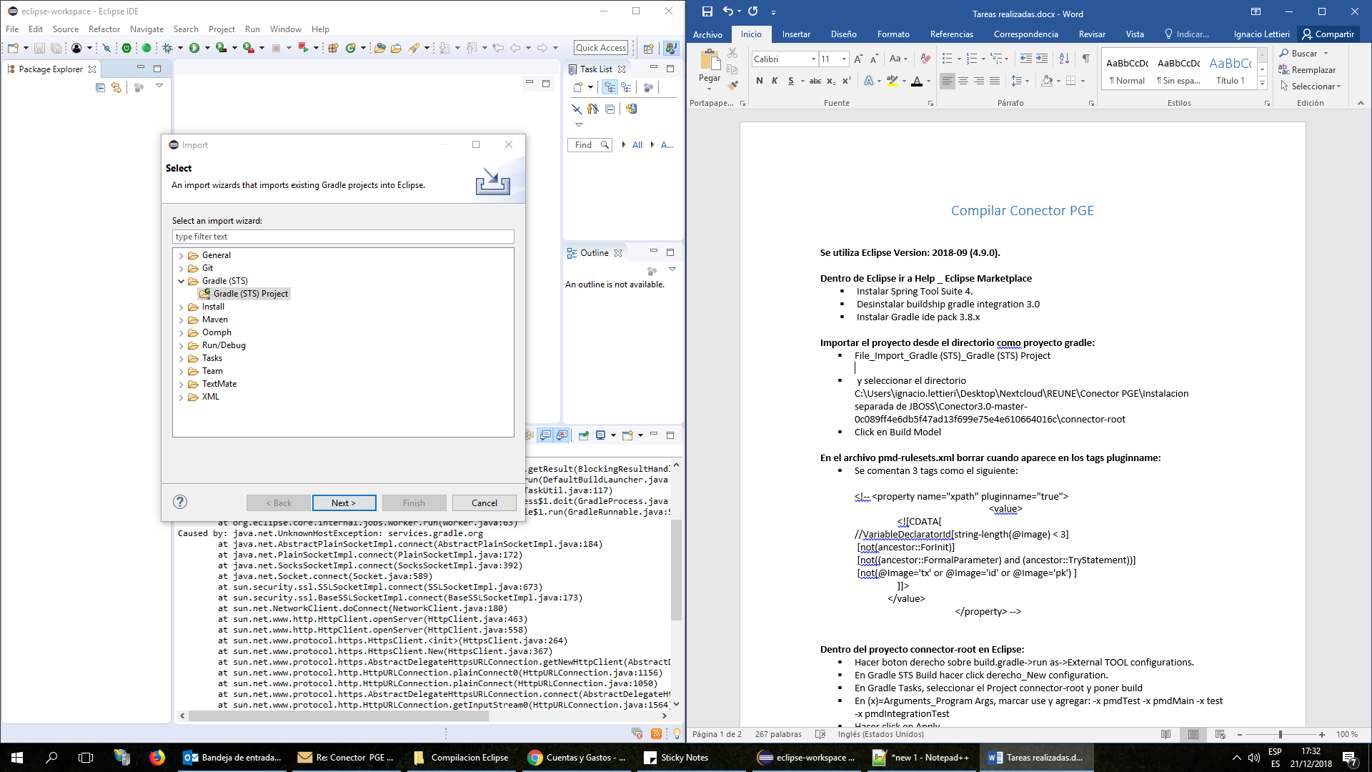

- Descomprimir el archivo Conector3.0-Fuentes.zip
- Seleccionar el directorio C:\Users\ignacio.lettieri\Desktop\Nextcloud\REUNE\Conector PGE\Compilacion Eclipse\Conector3.0-master-0c089ff4e6db5f47ad13f699e75e4e610664016c\connector-root y hacer click en Build Model

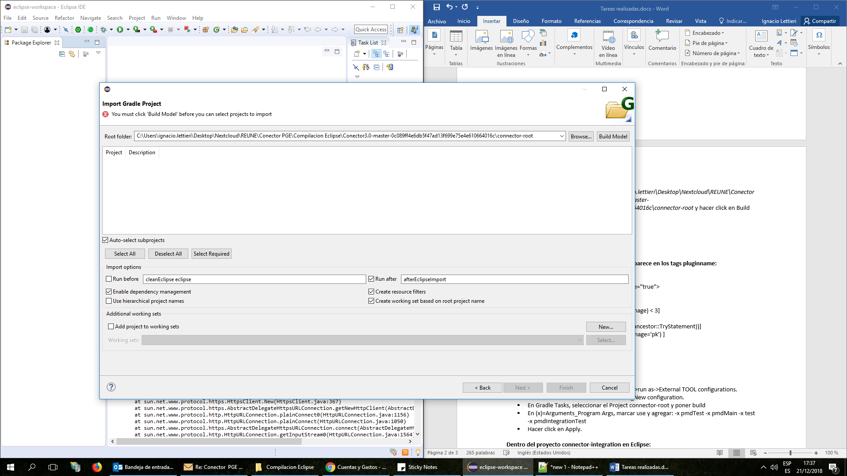

- Aparecen todos los proyectos. Seleccionar todos y hacer click en Finish

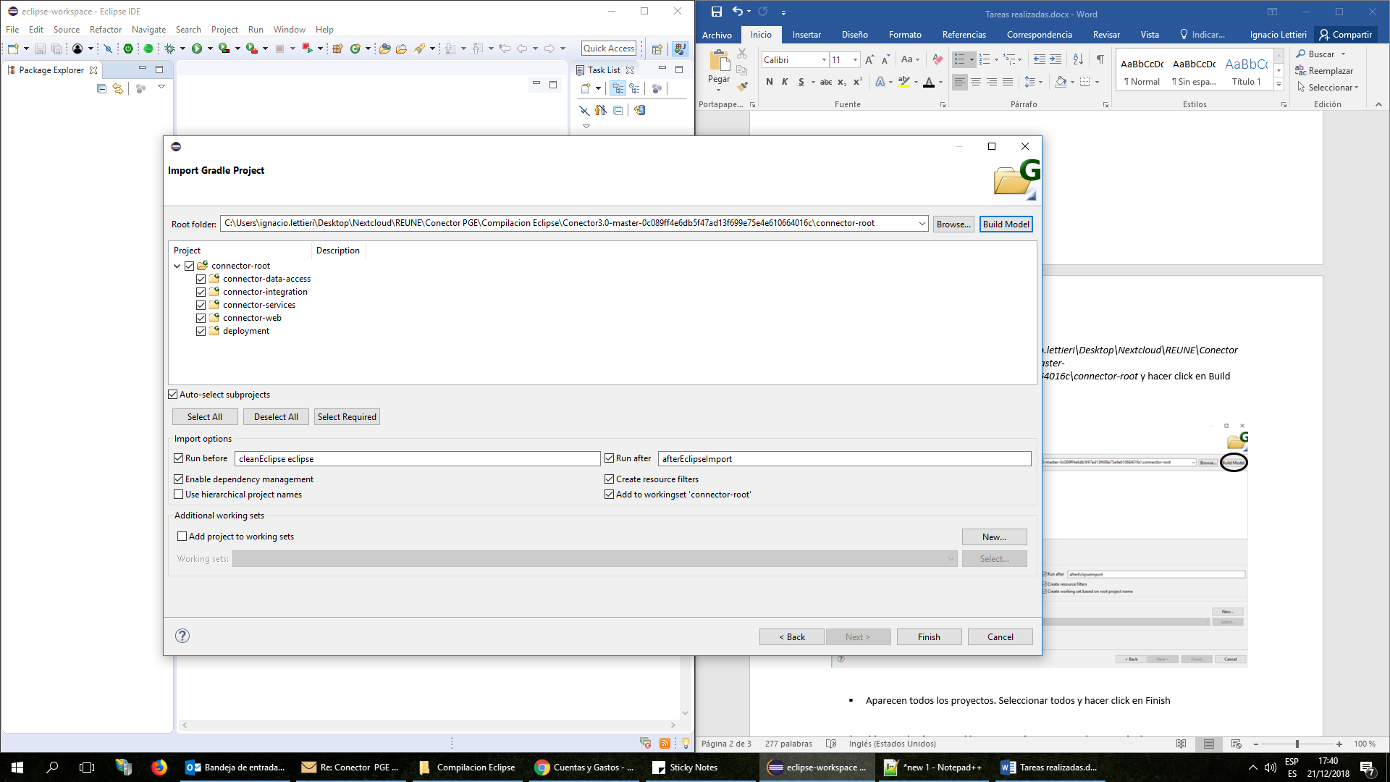

- Dentro del package connector-root en Eclipse:
- Abrir el archivo Conf_pmd_pmd-rulesets.xml y visualizarlo como código.

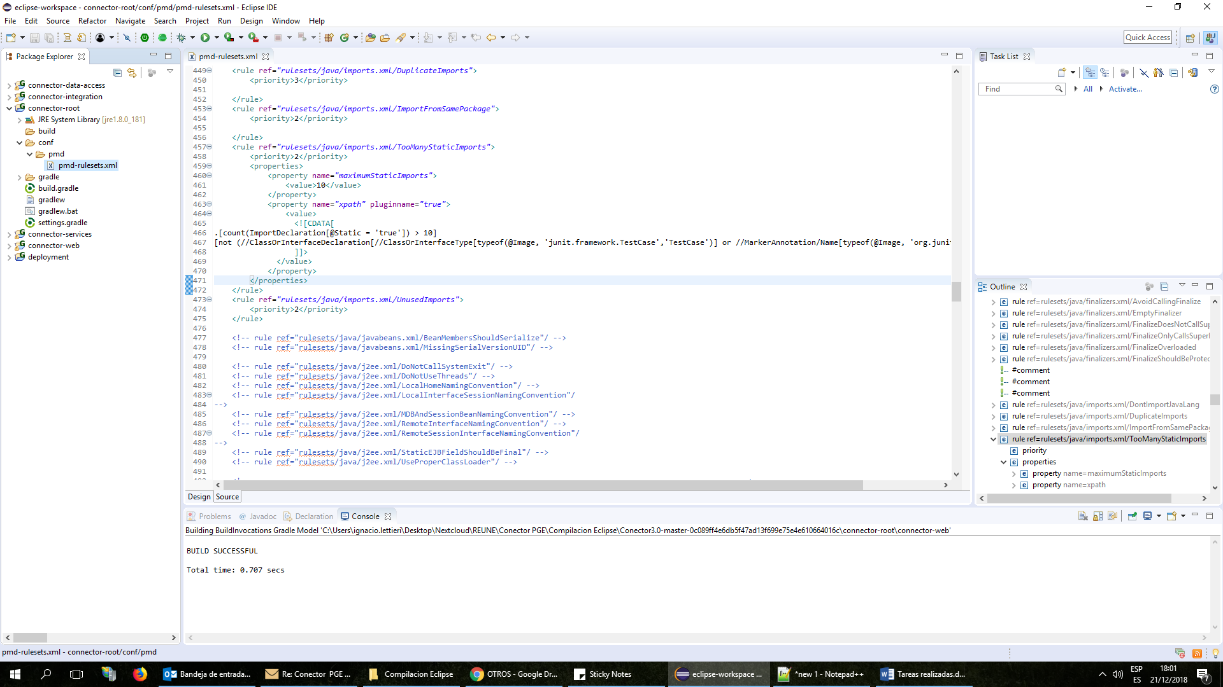

- Buscar “pluginname”

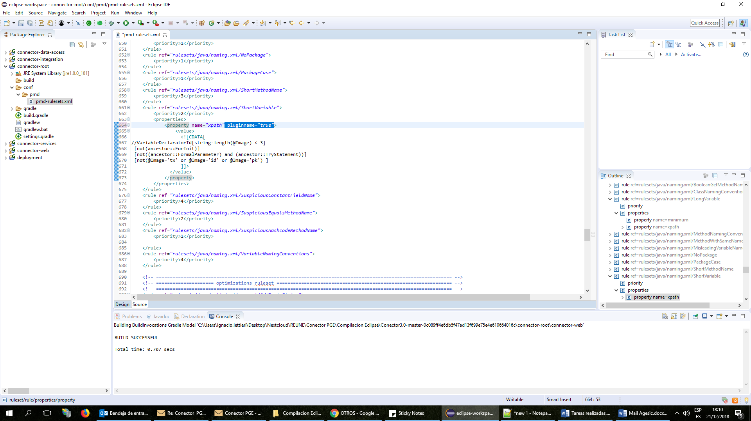

- Borrar todas las ocurrencias de pluginname="true"

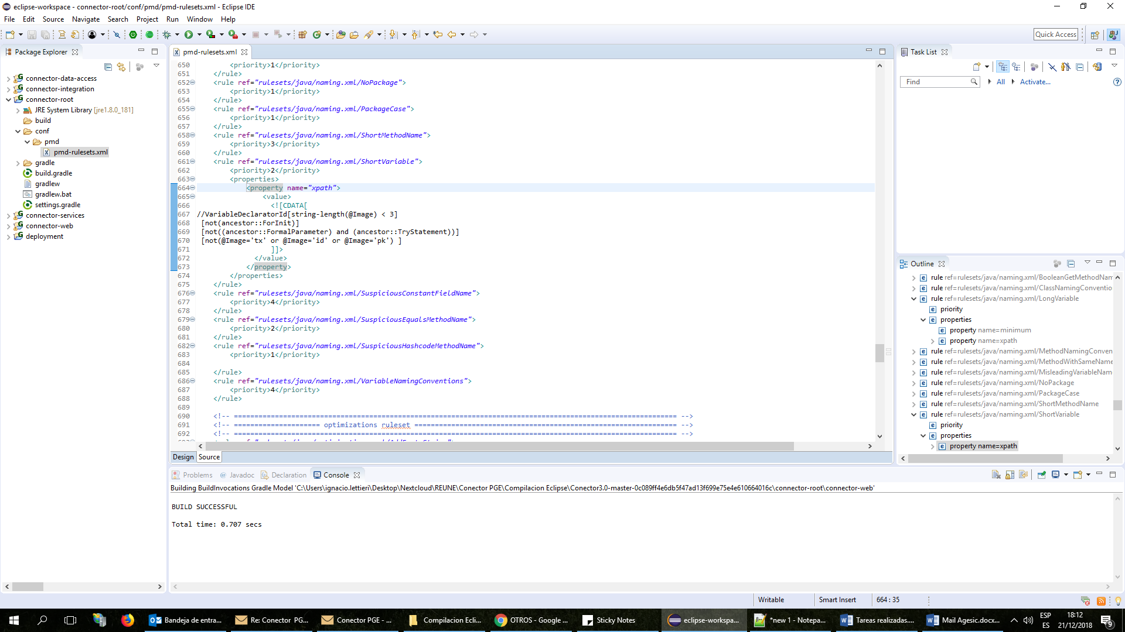

- Dentro del proyecto connector-root en Eclipse:
- Hacer boton derecho sobre build.gradle->run as->External TOOL configurations.

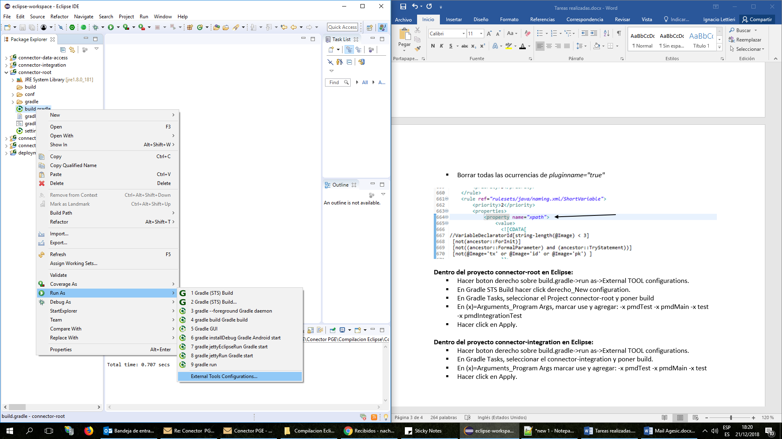

- Ir a Gradle (STS) Build y hacer click derecho_New configuration.

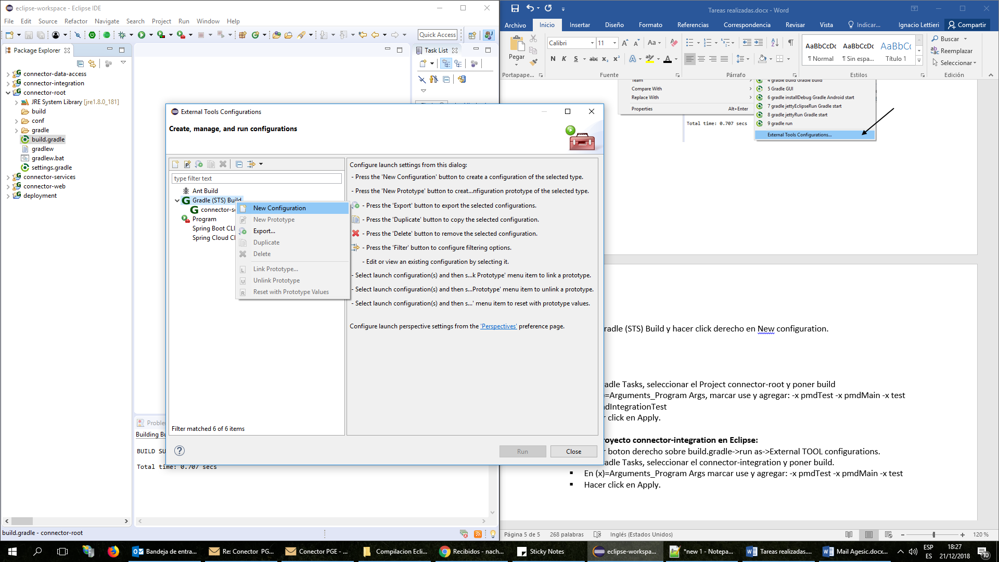

- Nombrar la nueva configuración como connector-root
- En la pestaña Gradle Tasks seleccionar el proyecto connector-root e ingresar build

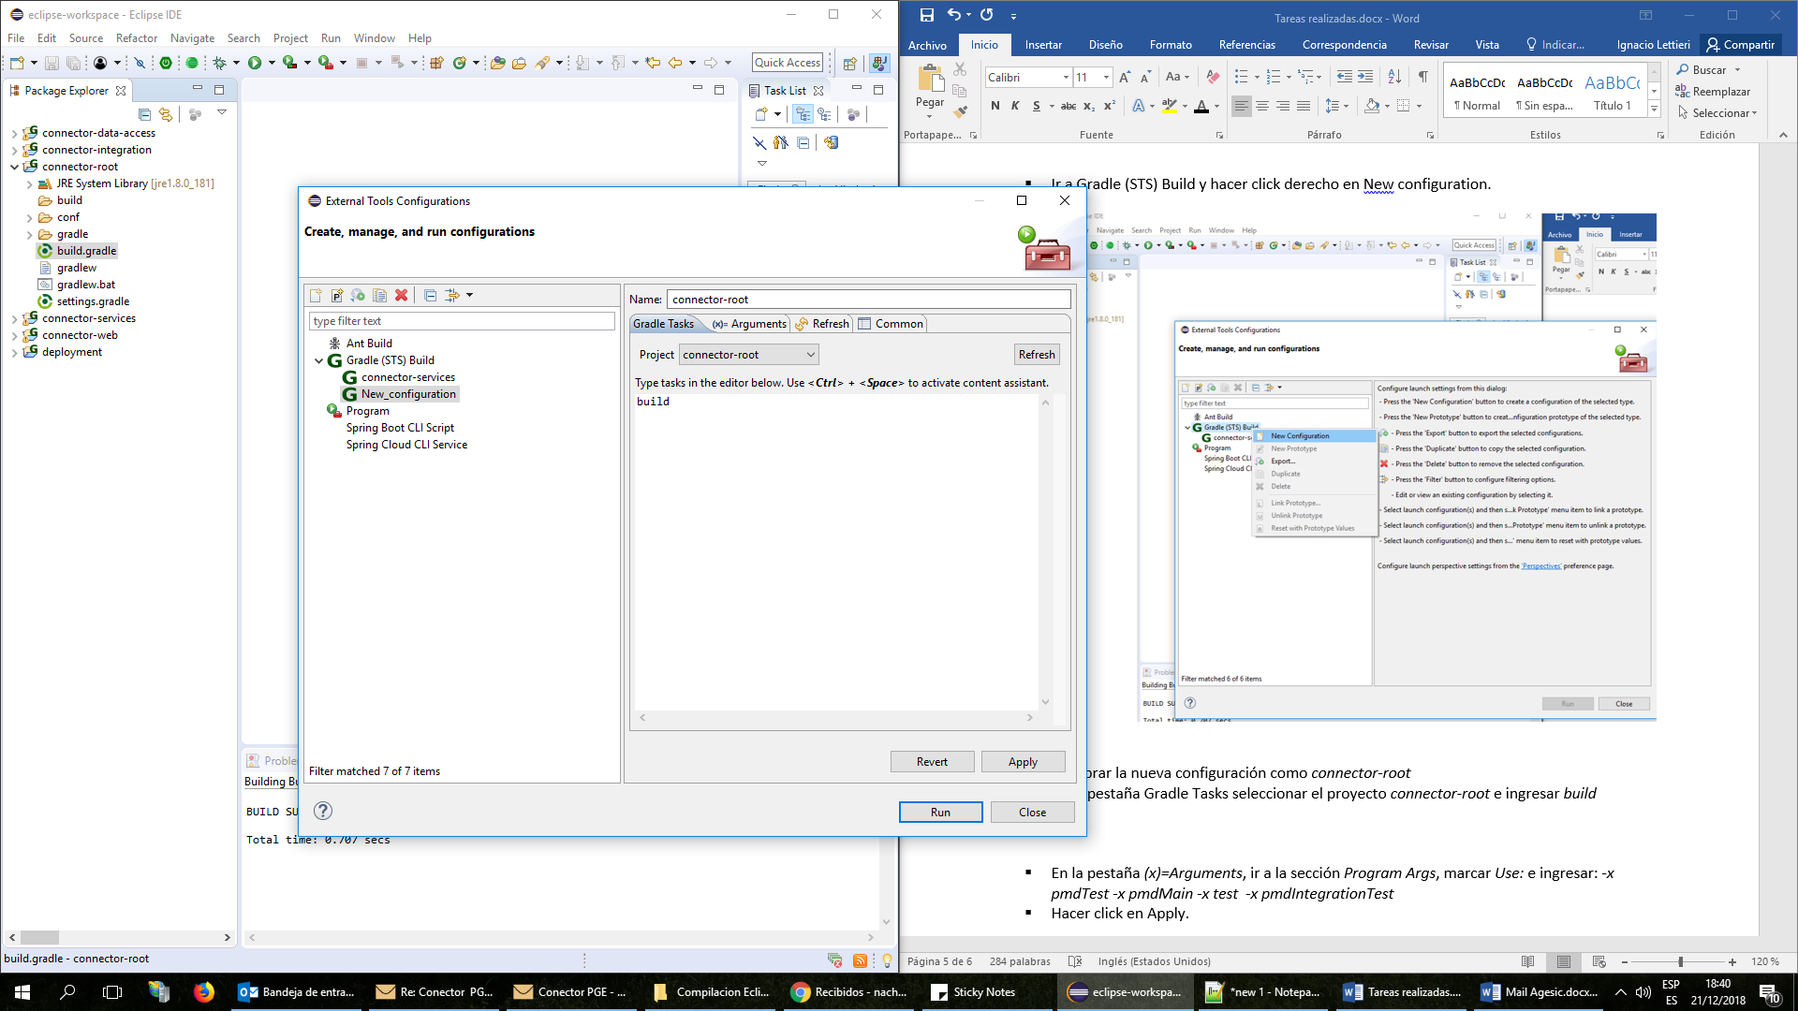

- En la pestaña (x)=Arguments, ir a la sección Program Args, marcar Use: e ingresar: -x pmdTest -x pmdMain -x test -x pmdIntegrationTest
- Hacer click en Apply y luego en Run.
- Resultado:

[sts] -----------------------------------------------------
[sts] Starting Gradle build for the following tasks:
[sts] build
[sts] -----------------------------------------------------
:connector-data-access:compileJava UP-TO-DATE
:connector-data-access:processResources UP-TO-DATE
:connector-data-access:classes UP-TO-DATE
:connector-data-access:jar UP-TO-DATE
:connector-data-access:assemble UP-TO-DATE
:connector-data-access:check
:connector-data-access:build
:connector-services:compileJava UP-TO-DATE
:connector-services:processResources UP-TO-DATE
:connector-services:classes UP-TO-DATE
:connector-services:jar UP-TO-DATE
:connector-integration:compileJava UP-TO-DATE
:connector-integration:processResources UP-TO-DATE
:connector-integration:classes UP-TO-DATE
:connector-integration:war UP-TO-DATE
:connector-integration:assemble UP-TO-DATE
:connector-integration:check
:connector-integration:build
:connector-services:assemble UP-TO-DATE
:connector-services:check
:connector-services:build
:connector-web:compileJava UP-TO-DATE
:connector-web:processResources UP-TO-DATE
:connector-web:classes UP-TO-DATE
:connector-web:war UP-TO-DATE
:connector-web:assemble UP-TO-DATE
:connector-web:check
:connector-web:build
:deployment:compileJava UP-TO-DATE
:deployment:processResources UP-TO-DATE
:deployment:classes UP-TO-DATE
:deployment:jar UP-TO-DATE
:deployment:assemble UP-TO-DATE
:deployment:check
:deployment:build
BUILD SUCCESSFUL
Total time: 1.398 secs
[sts] -----------------------------------------------------
[sts] Build finished succesfully!
[sts] Time taken: 0 min, 1 sec
[sts] -----------------------------------------------------

- Repetir el paso 4 para connector-integration

- Resultado:

[sts] -----------------------------------------------------
[sts] Starting Gradle build for the following tasks:
[sts] build
[sts] -----------------------------------------------------
:connector-data-access:compileJava UP-TO-DATE
:connector-data-access:processResources UP-TO-DATE
:connector-data-access:classes UP-TO-DATE
:connector-data-access:jar UP-TO-DATE
:connector-services:compileJava UP-TO-DATE
:connector-services:processResources UP-TO-DATE
:connector-services:classes UP-TO-DATE
:connector-services:jar UP-TO-DATE
:connector-integration:compileJava UP-TO-DATE
:connector-integration:processResources UP-TO-DATE
:connector-integration:classes UP-TO-DATE
:connector-integration:war UP-TO-DATE
:connector-integration:assemble UP-TO-DATE
:connector-integration:check
:connector-integration:build
BUILD SUCCESSFUL
Total time: 0.954 secs
[sts] -----------------------------------------------------
[sts] Build finished succesfully!
[sts] Time taken: 0 min, 0 sec
[sts] -----------------------------------------------------

- Repetir el paso 4 para connector-services quitando -x pmdIntegrationTest de la pestaña (x)=Arguments, sección Program Args.

- Resultado:

[sts] -----------------------------------------------------
[sts] Starting Gradle build for the following tasks:
[sts] build
[sts] -----------------------------------------------------
:connector-data-access:compileJava UP-TO-DATE
:connector-data-access:processResources UP-TO-DATE
:connector-data-access:classes UP-TO-DATE
:connector-data-access:jar UP-TO-DATE
:connector-services:compileJava UP-TO-DATE
:connector-services:processResources UP-TO-DATE
:connector-services:classes UP-TO-DATE
:connector-services:jar UP-TO-DATE
:connector-services:assemble UP-TO-DATE
:connector-services:check
:connector-services:build
BUILD SUCCESSFUL
Total time: 0.596 secs
[sts] -----------------------------------------------------
[sts] Build finished succesfully!
[sts] Time taken: 0 min, 1 sec
[sts] -----------------------------------------------------

